EwE tools for MSP –
software user guide

Author: Jeroen Steenbeek – Ecopath International Initiative
Date: 21 February 2018
Version: 1.7.2
Status: Pre-release
Document revisions
Version | Status | Date | Author | Description
0.1 | Initial | 01/03/2017 | JS | Started
0.5 | Draft | 27/03/2017 | JS | First draft
0.55 | Draft | 17/04/2017 | JS | Incorporated NHTV meeting feedback
0.8 | Draft | 10/05/2017 | JS | Described software changes
0.85 | Draft | 12/05/2017 | JS | Extensive debugging
1.0 | Submitted | 15/05/2017 | JS | Polished, submitted to RWS for review
1.1 | Revised | 22/05/2017 | JS | Updated to UI changes
1.3 | Revised | 26/05/2017 | JS | Updated to UI changes
1.4 | Revised | 01/06/2017 | JS | Updated to UI changes
1.4.1 | Revised | 23/08/2017 | JS | Added option to switch games to new scenarios
1.5 | Pre-release | 25/09/2017 | JS | Updated credits, added game data XML export
1.6 | Pre-release | 04/10/2017 | JS | Incorporated NHTV meeting feedback
1.6.1 | Pre-release | 2/11/2017 | JS | Updated to NHTV feedback
1.7 | Pre-release | 22/01/2018 | JS | Checks and debugging
1.7.1 | Pre-release | 15/02/2018 | JS | Fixed minor bug for NHTV
1.7.2 | Pre-release | 21/02/2018 | JS | Added test set load failure feedback
Copyright © 2017 Ecopath International Initiative Research Association, Barcelona, Spain

Scope
The Maritime Spatial Planning (MSP) Challenge 2050 serious game is an immersive, three-dimensional software system that educates stakeholders, planners and the general public about trade-offs and environmental consequences of planning decisions in the marine and coastal ecosystem over space and time (Stolte et al., 2013). The MSP software outsources its ecological calculations to the Ecopath with Ecosim (EwE) food web modelling approach (Christensen and Walters, 2004; Santos and Gonçalves, 2016; Steenbeek, 2016).
Although this integration opens up the possibility to use a large number of EwE models for MSP game play purposes, EwE models will need some adjustments to respond to environmental changes created by MSP game play. To support this adjustment process two MSP tools were developed as plug-ins to the EwE desktop.
This document provides a user guide to these tools, and is intended for EwE modellers who wish to adjust EwE models for MSP game play.

Requirements
MSP tools has the following system requirements:
- Microsoft Windows with EwE version 6.6 or newer installed (see http://ecopath.org);
- The EwE MSP plugin, available upon request from NHTV or EII;
- The Mono file access plug-in, available upon request from NHTV or EII.
The following scientific skills are recommended:
- Experience building Ecopath, Ecosim and Ecospace models;
- Experience fitting models to time series;
- Familiarity using the habitat foraging capacity model (Christensen et al., 2014);
- Familiarity with PreBal (Link, 2010) and EwE best practices (Heymans et al., 2016);
- Familiarity with the maritime ecology of the MSP game play area.

Acknowledgements
The EwE – MSP integration was funded by Rijkswaterstaat, The Netherlands.
The EwE – MSP integration was implemented by Jeroen Steenbeek (Ecopath International Initiative, Spain), in close collaboration with Carlos Santos, Magali Gonçalves, and Elwin Verploegen (NHTV University of Applied Sciences, The Netherlands).
Scientific support was provided by Johanna J. Heymans and Jacob Bentley (Scottish Association of Marine Science, Scotland), Giovanni Romagnoni (University of Oslo, Norway), and Marta Coll (Ecopath International Initiative, Spain).
Contents

1 Introduction 5
1.1 Terminology 6
1.2 Process overview 6
1.3 MSP tool basics 7
1.4 User interface conventions 7
2 Using MEL link designer 8
2.1 Managing games 8
2.1.1 Creating a game 8
2.1.2 Renaming or deleting a game 8
2.1.3 Loading a game from an MSP definition file 9
2.2 Configuring game settings 9
2.2.1 Switching scenarios 9
2.2.2 Spin-up years 9
2.2.3 Run years 10
2.2.4 MPA closure threshold 10
2.2.5 Ecospace diversity indicator calculations 10
2.2.6 Validation 10
2.3 Game information 10
2.3.1 Game version 10
2.3.2 Author 10
2.3.3 Contact 10
2.3.4 Description 11
2.4 Configuring pressures 11
2.4.1 Creating a pressure 12
2.4.2 Renaming and deleting a pressure 12
2.4.3 Restoring default pressures 12
2.4.4 Connecting pressures and drivers 12
2.4.5 Disconnecting a driver from a pressure 12
2.5 Configuring outcomes 13
2.5.1 Creating an outcome 13
2.5.2 Renaming and deleting an outcome 13
2.5.3 Defining the content of an outcome 14
3 Using MEL emulator 15
3.1 Running a simple MEL emulation 15
3.2 Running a MEL emulation using test sets 15
3.2.1 Creating a test set 16
3.2.2 Renaming and deleting a test set 16
3.2.3 Configuring a test set 16
3.2.4 Preparing test grids 17
3.2.5 Using a test set 17
3.2.6 Evaluating outcomes 17
4 Deploying a model 19
5 About MSP tools 20
6 References 21

Figures
Figure 1 – A conceptual diagram showing the conceptual linkage of the MSP game server and EwE software during MSP game play. Players take actions based on indicators. MEL translates actions into pressures, which influence the ecological model. EwE returns its predictions in the form of indicators. 5
Figure 2 – The two phases of updating a EwE model for MSP game play. During the preparation stage, EwE runs without the MSP software but will emulate a connection. During gameplay, the EwE MEL tools directly connect to the MSP software via MEL. 5
Figure 3 – An overview of the MSP tools terminology. A game identifies a EwE configuration to run for a MSP game, defines how MSP pressures translate to EwE drivers, and defines how EwE model predictions translate to outcomes (dark lines). 6
Figure 4 – The MSP tools screen docked in the EwE 6.6 desktop software. 7
Figure 5 – The MSP tools section to add, rename and remove games. 8
Figure 6 – The MSP tools section to configure the run settings of a game, and to check whether the EwE and game setup may conflict with MSP game play. 9
Figure 7 – The MSP tools game information section, where version and authorship data are entered. 10
Figure 8 – The MSP tools section to manage and configure pressures. In this example all MSP pressures for the North SEE case study are connected to Ecospace drivers. Effort drivers need a multiplier to translate MSP effort [0, 1] to Ecospace effort [0, ∞> 11
Figure 9 – The MSP section to manage and configure outcomes. In this figure the outcome “Indicator large fish” is configured as a portion of predicted Large demersal fish biomasses, divided by the sum of predicted demersal fish biomasses. 13
Figure 10 – The MSP tools MEL emulator section, with options to define and use simulated pressure data (test sets), and to interrupt and resume an Ecospace run. 15
Figure 11 – Defining simulated pressure data. First, sketch map content, and navigate to the map data grid (top). In the data grid, export the map data to an ASCII grid file (bottom) 18
Figure 12 - The About section of MSP tools, showing version information, a brief help text, developer and funding acknowledgements, an provides logos that link to the various websites of MSP project partners 20

Tables
Table 1 - Available Ecospace driver variables for MSP pressures 11
Table 2 - Available Outcome layer types 13

Introduction
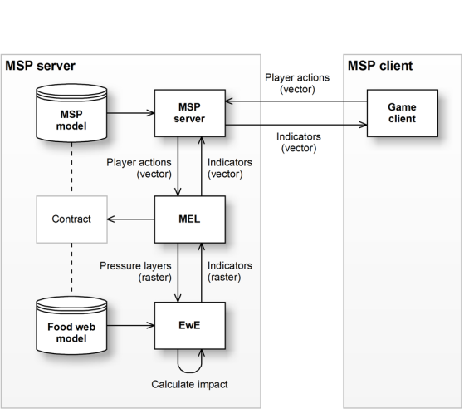
Figure 1 – A conceptual diagram showing the conceptual linkage of the MSP game server and EwE software during MSP game play. Players take actions based on indicators. MEL translates actions into pressures, which influence the ecological model. EwE returns its predictions in the form of indicators.
As described in detail in the MSP – EwE conceptual design documents (Santos and Gonçalves, 2016; Steenbeek, 2016), the EwE food web modelling approach connects to the MSP server via an intermediate process called MEL (MSP EwE Link). Within the MSP framework, MEL translates game player actions into pressures onto the ecology. EwE is responsible for calculating ecological impacts of these pressures and communicating results to MEL (Figure 1).
A standard EwE model will not be able to function for MSP game play purposes; it will require modifications. For instance, the MSP framework is a spatial-temporal explicit model requiring fast run times, which limits the number of functional groups and fleets in a model. MSP game players will introduce pressures to which the Ecospace model will need to respond with ecological realism. This requires introduction of responses to new external drivers, but this also means that the EwE scenario cannot run with any type of conventional environmental or fishing forcing as MSP game play will replace these drivers.
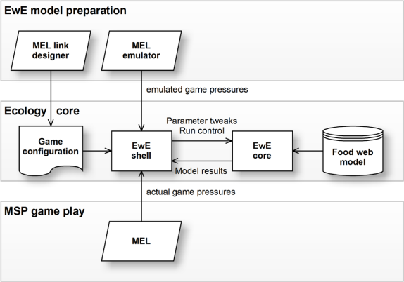
Figure 2 – The two phases of updating a EwE model for MSP game play. During the preparation stage, EwE runs without the MSP software but will emulate a connection. During gameplay, the EwE MEL tools directly connect to the MSP software via MEL.
EwE modellers adjust EwE models for MSP gameplay in the EwE desktop software. For practical reasons, EwE does not connect to the actual MSP game software during this stage; a model will have to undergo several modifications that require direct ecology testing with short and direct test paths. Once deployed, a finished model directly connects to the MSP framework via MEL (Figure 2).
Two tools for the EwE desktop software are available to support the task of configuring and testing how a model will behave under MSP game play scenarios: MEL link designer and MEL emulator.
MEL link designer allows a EwE modeller to configure how MSP game play actions influence Ecospace, and how Ecospace predictions aggregate back to MEL.
MEL emulator acts as a substitute for a live link to MEL during MSP game play, through which EwE modellers can use the familiar EwE desktop software to test how their model will behave when perturbed by emulated pressure data.
This document describes how to use these tools.

Terminology
The MSP tools introduce a few new concepts (see Figure 3):
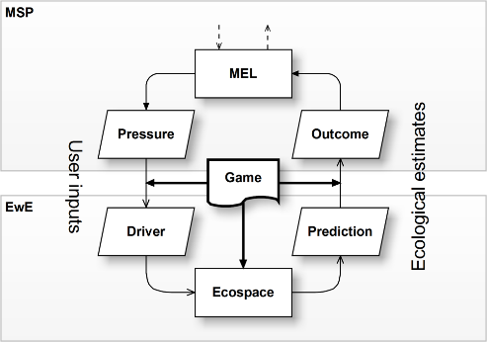
Figure 3 – An overview of the MSP tools terminology. A game identifies a EwE configuration to run for a MSP game, defines how MSP pressures translate to EwE drivers, and defines how EwE model predictions translate to outcomes (dark lines).
Game
A game is a specific configuration of EwE for an MSP scenario. Each game defines which Ecopath model, Ecosim scenario, Ecospace scenario, and a limited number of Ecospace run settings, are needed to play the MSP game. A game also defines how MSP affects Ecospace, and how Ecospace output is sent back to MSP. Note that the NHTV design documents use the word “mode” to refer to a “game”.
Pressures
A game is used to explore the impact of MSP player activities onto the EwE food web. MEL (see Figure 1) converts MSP player actions into one or more pressures. Pressures can be spatial (e.g., occur in different intensities across the MSP game area) or nominal (e.g., a single multiplier) to affect Ecospace variables.
Drivers
Ecospace input variables that are able to receive pressure values, and thus influence the EwE food web, are referred to as drivers in the MSP tools.
Outcomes
Ecospace sends model predictions fed back to the MEL (see Figure 1) as spatial grids called outcomes.

Process overview
Making a EwE model fit for MSP game play is an iterative process that involves the following steps:
- Identify the MSP game play needs for the ecological model;
- Update EwE model structure to match the MSP game play needs;
  - Update Ecopath (groups, fleets);
  - Update Ecosim (refit if possible, remove temporal drivers);
  - Update Ecospace (define base map, remove spatial-temporal drivers);
- Connect EwE to MSP;
  - Define Ecospace drivers to receive MSP game play pressures;
  - Define outcomes that will need to be sent back to MSP;
  - Connect MSP pressures to Ecospace drivers;
  - Connect MSP outcomes to Ecospace predictions;
- Test how Ecospace responds with simulated pressure data;
- Test how Ecospace responds with MSP-derived pressure data.
Steps 1 and 2 are discussed in the EwE modeller checklist. This document focuses on steps 3 to 5, connecting a EwE model to the Maritime Spatial Planning game.

MSP tool basics
When an Ecospace scenario is loaded in the EwE desktop software, the MSP tools is launched by navigating to Main menu > Tools > MSP tools. The MSP tools screen open as shown in Figure 4.
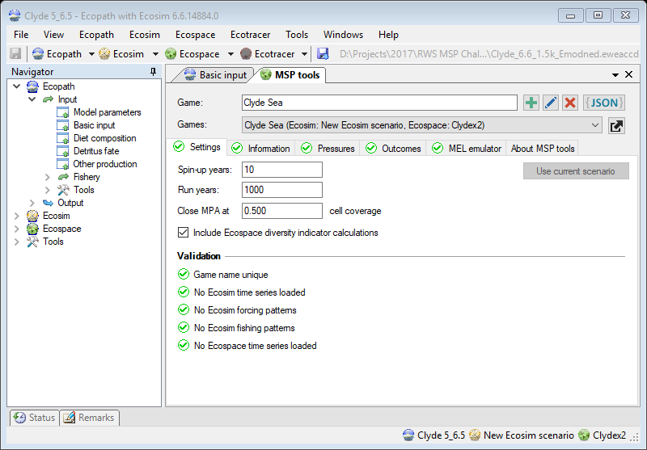
Figure 4 – The MSP tools screen docked in the EwE 6.6 desktop software.
In the MSP tools screen users can create and delete games, and configure games to accept pressures and produce outcomes. Users can also test model responsiveness to emulated game play actions.

User interface conventions
MSP tools uses the following conventions:
Action icons
MSP tools uses action icons for adding, for renaming, and for deleting features.
Status icons
MSP tools uses status icons to validate the state of input: indicates all is well, indicates that item(s) may require your attention, and indicates errors or insufficient data to proceed.
Work flow
The MSP tools have been testing for robustness, but may not be fully responsive to adding and removing Ecospace layers, habitats, MPAs etc. As a recommendation, keep the MSP tools screen closed when altering the structure of an Ecospace scenario.
A game configuration and test sets cannot be altered while Ecospace is running.
Saving
MSP tools stores its data with the EwE model when you save the model. Please save often.

Using MEL link designer

Managing games

Figure 5 – The MSP tools section to add, rename, and remove games.
The games section allows creation, renaming, and deletion of games (Figure 5). Games defined within in the current loaded model are shown; note that also the names of the Ecosim and Ecospace scenario used by the game are shown in the games list.

Creating a game
The first step to connecting EwE to a given MSP scenario is to define a game. When you create a game, that game will use the currently loaded Ecosim and Ecospace scenario as last saved.
To create a game, do the following:
- Enter a name in the game name field;
- Press the Add game button ( ).
The new game is created and is selected. The game configuration area becomes editable: here you can now configure the game for MSP game play. Note that game names are restricted to 128 characters in length.
Note that a game name must correspond to a game mode defined in the MSP software. Make sure the game name and its exact spelling are in agreement with the MSP software settings.

Renaming or deleting a game
To change the name of a game, do the following:
- Select the game in the games dropdown;
- Enter a new name in the game name field;
- Press the rename game button ( ).
Note that the MSP tools do not enforce unique game names. Game names should be unique, of course, but the MSP tools do not check this yet.
To delete a game, do the following:
- Select the game in the games dropdown;
- Press the delete game button ( ).
Note that deletion is permanent, and MSP tools does not ask for confirmation whether the delete operation should proceed!

Loading a game from an MSP definition file
The MSP game framework uses a JSON file for each game, which defines the game layout. MSP tools can load this type of file to define a game compatible with the MSP setup. Loading this file will perform the following tasks at once:
- Validate Ecospace compatibility with the MSP game requirements;
- Define a new game;
- Define pressures;
- Define outputs.
To load a JSON game configuration file, do the following:
- Press the load JSON file button ( );
- Browse to the JSON file that describes the game, and load it.
To export the configuration of all defined games to an XML file, do the following:
- Press the Export button ( ). The XML file will be placed beside your model file.

Configuring game settings
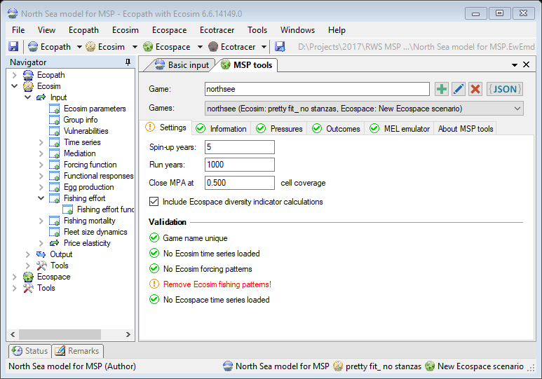
Figure 6 – The MSP tools section to configure the run settings of a game, and to check whether the EwE and game setup may conflict with MSP game play.
The game settings section (Figure 6) is used to configure Ecospace model execution parameters specific for MSP game play, and provides a validation whether unwanted drivers are present in Ecosim and Ecospace.

Switching scenarios
The ‘Use current scenario’ button will be enabled if the current game is linked to an Ecospace scenario that is not currently loaded. Click this button to have the game use the currently loaded scenario.

Spin-up years
The spin-up period or burn-in period is an Ecospace stabilization period, during which Ecospace dynamics stabilize before the model can start producing output. MSP needs a spin-up period if Ecospace, launched with MSP starting conditions, shows significant biomass fluctuations. The ecology should be stable without player actions.
The length of the spin-up period (in years) depends on the length of time (in years) it takes for Ecospace to reach stable dynamics with MSP starting conditions. When the MSP framework launches EwE, Ecospace executes this spin-up period before model time stepping can begin.
Use the shortest spin-up period necessary to reach stable Ecospace dynamics with MSP start-up conditions in place.

Run years
Each MSP game play runs for a finite number of years. The Ecospace run length (in years) should be long enough to accommodate a MSP game play session. The default value is 1000 years, which should be enough under most circumstances, but hey, you never know.

MPA closure threshold
Ecospace Marine Protected Area cells are either open or closed to fishing. Ecospace does not support partial closure of a cell to fishing. MSP protection layers will deliver cell area fractions covered by protection. By default, there is no fishing when a protection measure covers up 25% or more of a cell, but this threshold can be changed.

Ecospace diversity indicator calculations
This option, which is off by default, instructs Ecospace to calculate the Kempton Q and Shannon Diversity Indicator. These calculations are costly in terms of performance.
Only enable this option if a MSP game requires the display of biodiversity indicators.

Validation
The validation section shows alerts if EwE and game settings will cause problems for MSP game play: a game name must be unique, and Ecosim and Ecospace may not contain temporal forcing patterns.
Fix all warnings in the validation section prior to delivering a model for game play.

Game information
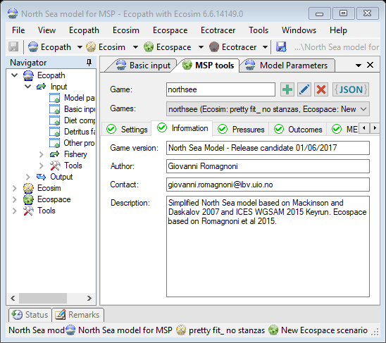
Figure 7 – The MSP tools game information section, where version and authorship data are entered.
The section (Figure 7) contains game metadata such as version, authorship, and contact info.

Game version
Each game must have a brief version descriptor that uniquely identifies a game version.
Although the MSP game does not use this information, MSP developers can tell you which of your versions is running on their server. Sometimes an older file ends up on the game server, and without proper game versioning, you would never have known.
Diligently keep a log of model versions, and update version information when a game has changed.

Author
Enter your name here. This information is optional, and is limited to 128 characters

Contact
Enter your contact information (email address, phone number, social network ID, etc) here. This information is optional, and is limited to 200 characters.

Description
Enter a brief summary of the game setup here (its strengths and weaknesses, foreseen improvements, models, publications, etc.) This information is optional, and is limited to 2000 characters.

Configuring pressures
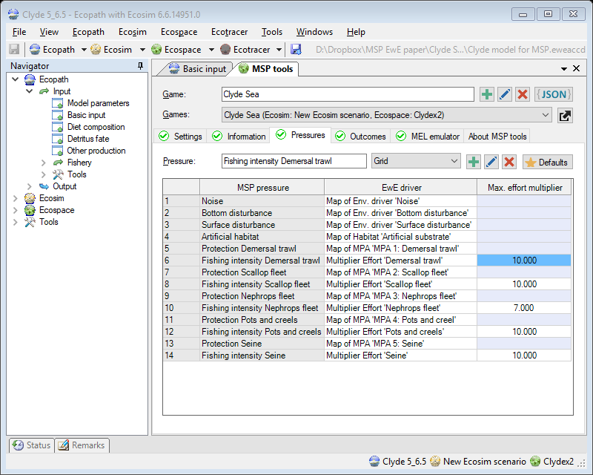
Figure 8 – The MSP tools section to manage and configure pressures. In this example, all MSP pressures for the North SEE case study are connected to Ecospace drivers. Effort drivers need a multiplier to translate MSP effort [0, 1] to Ecospace effort [0, ∞>
Pressures represent environmental disturbances caused by game player actions that affect the marine food web. Each pressure has a unique name, and pressure data sent to EwE during game play is identified by these names.
The purpose of this section is to connect pressures to the EwE driver variables, to impact the ecological calculations.
The MSP tools - game pressures section (Figure 8) shows defined pressures (left column) and their impacting EwE driver variables (right column), if any. Available Ecospace driver variables are:
Table 1 - Available Ecospace driver variables for MSP pressures
Driver variable | Description | Type | Value range
Map of MPA ‘..’ | A MPA map defines the cell layout of an Ecospace MPA (Ecospace > Input > Maps > MPA). Ecospace uses 0 and 1 values to identify MPA map cells; incoming fractional values are translated to 0 or 1 according to the MPA closure threshold value (see § 2.2.4) | Grid | 0 | 1
Map of Habitat ‘..’ | A habitat map defines the fraction of cell area covered by a single habitat type (Ecospace > Input > Maps > Habitat) | Grid | [0, 1]
Map of Env. Driver ‘..’ | An environmental driver map defines driver intensity across the map (Ecospace > Input > Maps > Environmental driver) | Grid | [0, 1]
Multiplier effort ‘..’ | An effort multiplier acts as a multiplier onto base effort of a fleet (Ecospace > Input > Ecospace fishery > Fleet Dynamics > Total effort multiplier) | Scalar | [0, 1]

Please be aware that MSP specifies effort multipliers on a range of [0, 1], representing minimal to maximal fishing, while the Ecospace Effort Multiplier has no upper bound. MSP modellers will need to define a value for this upper bound, which should be set to the relative Ecosim effort needed to wipe out targeted groups within four years, and is entered in the pressures grid. This maximum effort value is used to scale MSP effort values of [0, 1] to actual Ecospace Effort Multiplier values.

Creating a pressure
To create a new pressure, do the following:
- Enter a name in the pressure name field;
- Select the pressure type, which can be either a grid (e.g., a map with a pressure values, destined for a Ecospace map layer) or a scalar (e.g., a multiplier to be applied to an Ecospace input parameter), see Table 1;
- Press the Add pressure button ( ).
The new pressure will be created and will be added to the pressure / drivers table. Note that pressure names are limited to 128 characters in length.

Renaming and deleting a pressure
The name of a pressure can be changed as follows:
- Select a pressure row in the pressure table;
- Enter a new name in the pressure name field;
- Press the rename pressure button ( ).
Note that the MSP tools do not enforce unique pressure names. Ensure that pressure names are unique and are spelled correctly. Pressure names are not case-sensitive
Deleting a pressure is straightforward too:
- Select a pressure row in the pressure table;
- Press the delete pressure button ( ).

Restoring default pressures
If the default pressures need to be restored, do the following:
- Press the default pressures button ( Defaults).

Connecting pressures and drivers
Once all MSP pressures have been defined, the ecological model must be made to respond to these pressures. Table 1 shows the limited range of driver variables that pressures are allowed to impact.
To select a driver for a pressure, do the following:
- Double-click the EwE driver cell in row of the MSP pressure that you wish to impact the model;
- Select the desired driver from the dropdown list that pops up;
- For effort drivers, enter the maximum effort multiplier (see § 2.4).

Disconnecting a driver from a pressure
To clear a driver from a pressure, do the following:
- Double-click the EwE driver cell in row of the MSP pressure that you wish to impact the model;
- Select the first empty row from the dropdown list that pops up.

Configuring outcomes
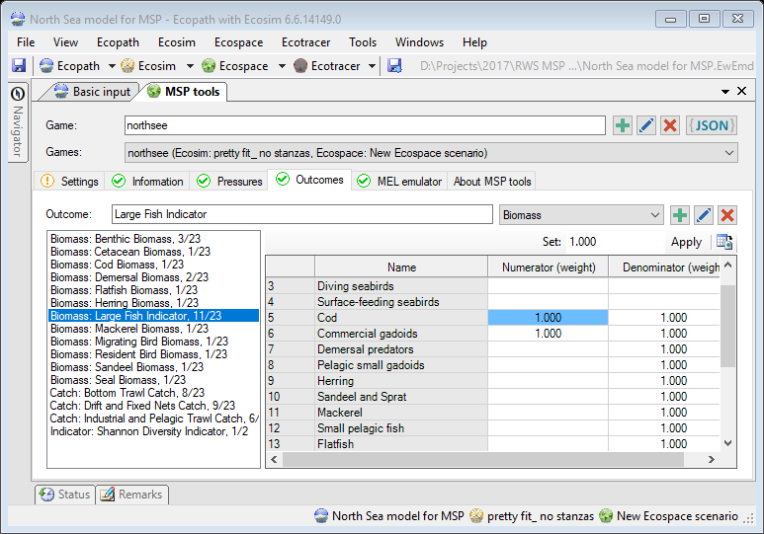
Figure 9 – The MSP section to manage and configure outcomes. In this figure, the outcome “Indicator large fish” is configured as a portion of predicted large demersal fish biomasses, divided by the sum of predicted demersal fish biomasses.
Outcomes are Ecospace predictions that are sent back to MEL for dissemination to MSP game participants. For identification and display purposes, each outcome has a unique name. As summarized in Table 2, an outcome contains a grid with an aggregation of one or more Ecospace predictions, which can be functional group biomasses (for biomass outcomes), functional group catches (for catch outcomes), fleet effort (for effort outcomes), or a biodiversity indicator (for diversity outcomes).
Table 2 - Available Outcome layer types
Outcome type | Description | Aggregation | Unit
Biomass | Map of the sum of biomasses of one or more functional groups | Functional group | t/km2
Catch | Map of the sum of catches of one or more functional groups across all fleets | Functional group | t/km2
Effort | Map of the sum of fishing effort of one or more fleets | Fleet | t/km2
Indicator | Map with the spatial distribution of a biodiversity indicator | N/A | Depends

Creating an outcome
To create a new outcome, do the following:
- Enter a name in the outcome name field;
- Select the outcome type (see Table 2);
- Press the Add outcome button ( ).
The new outcome will be created and will be added to the outcomes table. Note that outcome names are limited to 128 characters in length.

Renaming and deleting an outcome
The name and type of an outcome can be changed as follows:
- Select an outcome row in the pressure table;
- If desired, enter a new name in the outcome name field;
- If desired, select a new outcome type;
- Press the rename outcome button ( ).
Note that the MSP tools do not enforce unique outcome names. Outcome names should be unique and should be spelled exactly as defined in the MSP game.
Deleting an outcome is straightforward too:
- Select an outcome in the outcome table;
- Press the delete outcome button ( ).

Defining the content of an outcome
When selecting an outcome that requires aggregation of group or fleet predictions, these groups or fleets will be shown. To define how much of each groups (biomass, catch, or indicator) or fleet (effort) predictions should be included in the outcome, enter the weight that each group or fleet contributes to the nominator in the outcome.
For indicator outcomes, weights can also be entered for group biomass contributions to the denominator in the outcome. The outcome value o for a cell is then simply defined as
$$o=\frac{\sum_{i=1}^{k}{b_{i}×n_{i}}}{\sum_{i=1}^{k}{b_{i}×d_{i}}}$$
where k = number of functional groups in the model, b_{i} = predicted biomass of functional group i in the cell, n_{i} = numerator weight defined in the outcome for functional group i, and d_{i} = denominator weight defined in the outcome for functional group i.

Using MEL emulator
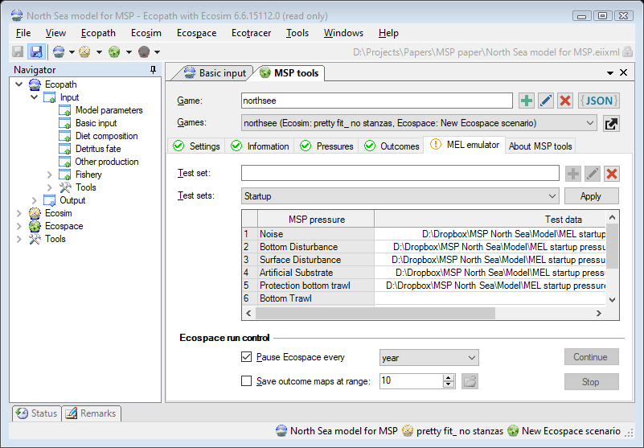
Figure 10 – The MSP tools MEL emulator section, with options to define and use simulated pressure data (test sets), and to interrupt and resume an Ecospace run.
Once a game is defined, pressures are connected to drivers, and outcomes are provided with content, MEL emulator can be used to test the response of the food web to fictional MSP pressure content, and MEL outputs can be saved to disk for detailed scrutiny.
The MEL emulator section (Figure 10) allows EwE modellers to pause an Ecospace run, inject simulated pressure data into the running scenario, and continue running. If desired, MSP outcomes can be saved to disk. Outcome layer grids will be written to a path defines as: [Ecospace output location]\MSP\[Game name]. The EwE status panel will show notifications when output grids have been written to file, and the MEL emulator section contains a file open icon ( ) to open the MEL output folder in Windows File Explorer if this folder is present.
Note that outcome maps are formatted for display purposes in 100 discrete intervals on a scale from 0 to 1, where 0.5 represents no change in relation to the Ecopath baseline value, while to upper limits of 0 and 1 represent a deviation of 1/n to n times the Ecopath baseline value, respectively. The magnitude scale n is controlled though the output range parameter in Figure 10, which is set to 10 by default. This scaling approach greatly simplifies outcome display logic in the MSP software.

Running a simple MEL emulation
Run the simplest MEL emulator scenario, where MEL emulator is only used to pause Ecospace at a known interval, as follows:
- In the MEL emulator section, set Ecospace to automatically pause at any interval;
- Go to Navigator > Ecospace > Output > Run Ecospace, and start the Ecospace run;
- When Ecospace pauses, update the content of desired pressure layers by sketching or importing map data in Navigator > Ecospace > Input > Maps;
- Continue the run (either from the Run Ecospace screen or from the MEL emulator section) and see the impact of new pressure data on the food web.
A subtle woodblock sound will play when MEL emulator pauses Ecospace.

Running a MEL emulation using test sets
The MEL emulator section offers test sets to make it easier to use a test data pattern many times. A test set defines simulated pressure data, effectively mimicking a live connection to the MSP software, to test the impact of varying pressure content on the EwE model.
Test sets can be defined, renamed, deleted, and configured.
Note that test sets are stored in [user profile]\Roaming\Ecopath with Ecosim\MSP_testsets.xml. Test sets are shared between all MSP games created for the same EwE model and Ecospace scenario.

Creating a test set
To create a new test set, do the following:
- Enter a name in the test set name field;
- Press the Add test set button ( ).
The new test set will be created, will be selected, and its content will be shown for editing.

Renaming and deleting a test set
The name and type of a test set can be changed as follows:
- Select a test set row in the test set drop down;
- Enter a new name in the test set name field;
- Press the rename test set button ( ).
Deleting a test set is straightforward as well:
- Select a test set row in the test set drop down;
- Press the delete test set button ( ).

Configuring a test set
As outlined in Table 1, pressure data can be fed to two types of Ecospace drivers:
Maps provide values for every Ecospace cell. Map test data can be read from ESRI ASCII maps and RGB TIF files as used and produced by MEL. Map values can range from zero to one, or can hold a NoData value that must be specified in the map format. EwE uses a default NoData value of -9999.
Scalars are multipliers to an Ecospace input parameter. Scalar test data is entered as a single number between zero and one, or NoData (-9999) if a scalar should not affect the model. When you clear a scalar pressure cell NoData is assumed.
To connect test data to a test set, do the following:
- In the MEL emulator section, click a test data cell;
- If the connected pressure is a grid, a file selection form pops up. Use this to browse to the desired map file with test data. Select the desired file and press [OK];
- If the connected pressure is a scalar, enter the scalar value directly in the cell.
Note that test data can only be assigned to pressures that are connected to Ecospace drivers.
Note that test data can only be defined or edited when Ecospace is not running.
To disconnect test data from a test set, do the following:
- In the MEL emulator section, move to the cell you wish to clear;
- Press [Delete] or [Backspace] to clear the value of that cell.

Preparing test grids
Preparing gridded test data is a straightforward process in the EwE desktop software (Figure 11):
- In the Ecospace Maps screen (Navigator > Ecospace > Input > Maps), sketch pressure data into the desired map layer;
- Double-click the name of the map layer and open the Data tab for the layer;
- Export the map content to an ASCII file. The map file is now ready to be used as pressure test data.

Using a test set
Test sets can be loaded into Ecospace when either Ecospace is idle (e.g., a scenario has been loaded and Ecospace is not running) or when Ecospace is running and is paused.
To load Ecospace drivers with emulated MSP pressure data in a test set, do the following:
- When Ecospace is idle or Ecospace is paused, select a test set;
- Press the apply test set button ([Apply]).
When preparing and using test sets, the following simple rules apply:
- No data? No change!
Test sets can define simulated pressure data for multiple pressures at once, but it does not need to provide test data for all pressures. Only pressures that receive test data will affect their Ecospace drivers;
- Pressure values
Pressure data can contain three types of values. Non-zero values indicate a presence of a pressure of some sort. Zero values indicate an absence of a pressure. Unknown values (or -9999) indicate that a pressure value is unknown. Unknown cell values are not applied to Ecospace, and the value(s) in the Ecospace driver variable value are left intact;
- Be careful when testing
Simulated pressure data will be loaded straight into Ecospace input variables. If a model with test data is saved, your Ecospace scenario will be permanently altered!
Be careful not to accidentally save test data in your scenario!

Evaluating outcomes
The impact of emulated MSP pressures can be assessed through the usual Ecospace diagnostics: the maps and graph in the Run Ecospace screen, the Ecospace run summary, and via auto-saved output that Ecospace can write to disk by default. In addition, the MEL emulator screen offers the ability to write the content of outcome layers to disk as well.
Working experience with MSP tools is now needed to determine if these diagnostics are sufficient to assess the impact of MSP pressures onto the EwE model. Other diagnostics tools may be needed and can be foreseen, such as a way to visualize outcome layers within MSP tools.

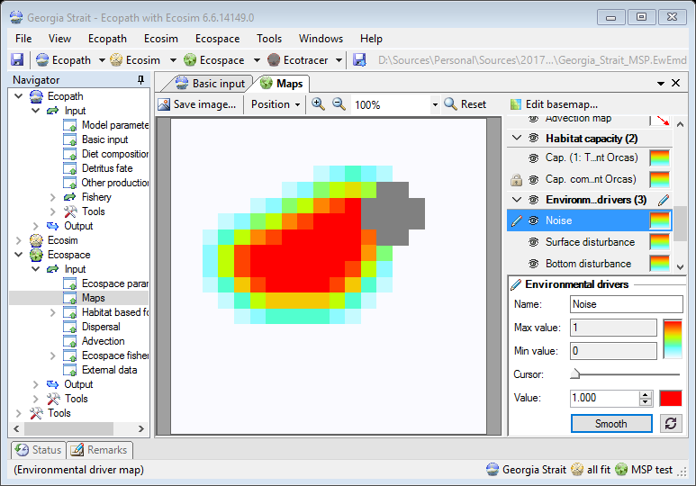
Double-click the layer, here
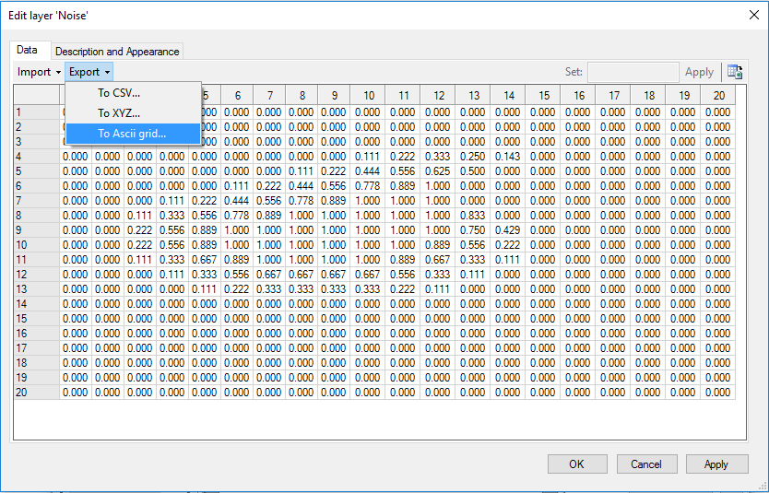
Figure 11 – Defining simulated pressure data. First, sketch map content, and navigate to the map data grid (top). In the data grid, export the map data to an ASCII grid file (bottom)

Deploying a model
Once a EwE model is prepared for MSP game play, it will need to be converted to an .eiixml file. The .eiixml format is a flat text version of the EwE model database that allows loading EwE models on computer systems where Microsoft Access is not available. The .eiixml format is used in MSP to avoid having to maintain database drivers on the MSP game server.
EwE version 6.6 can natively export model databases to this data format.
With the MSP model loaded in the EwE6 desktop software, convert it to an .eiixml file as follows:
- Launch the conversion method via Menu > File > Export > To XML;
- EwE may want to save pending changes. If this is declined the export process is halted;
- The EwE status panel will show a clickable link to the exported .eiixml file.
Note that it is highly recommended to address all warnings and errors in MSP tools before exporting a model for MSP game deployment.
The EwE status panel will show a message whether the file export process was successful. If the process was successful, the .eiixml file will be created beside the loaded model database. This file now can be sent to NHTV for integration with the MSP game server.
Note that EwE 6 can also load and run .eiixml files through the regular Menu > File > Open command. At the time of writing .eiixml model databases will be opened as read-only, since the EIIXML database format has not been extended to include dynamic object creation.

About MSP tools
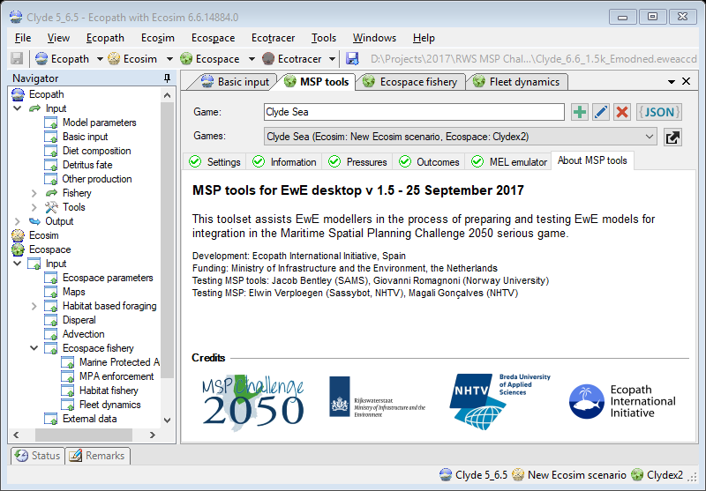
Figure 12 - The About section of MSP tools, showing version information, a brief help text, developer and funding acknowledgements, an provides logos that link to the various websites of MSP project partners
The last tab in the MSP tools interface is the ‘About’ page, where generic information about the MSP tool set is included.
Here, MSP tools version information serves to validate whether the correct version of MSP tools is installed. A brief description of MSP tools is provided for unaware EwE modellers that stumble upon the plug-in. Developer and funding credits are provided. Last, logos of all project partners involved in integrating the EwE modelling approach into the ecological assessments of MSP are shown. Clicking a logo will open the website of that partner.

References
Christensen, V., and Walters, C.J. (2004). Ecopath with Ecosim: methods, capabilities and limitations. Ecol. Model. 172, 109–139.
Christensen, V., Coll, M., Steenbeek, J., Buszowski, J., Chagaris, D., and Walters, C.J. (2014). Representing Variable Habitat Quality in a Spatial Food Web Model. Ecosystems 1–16.
Heymans, J.J., Coll, M., Link, J.S., Mackinson, S., Steenbeek, J., and Christensen, V. (2016). Best practice in developing, balancing, fitting and using Ecopath with Ecosim food-web models for ecosystem-based management. Ecol. Model. 331, 173–184.
Link, J.S. (2010). Adding rigor to ecological network models by evaluating a set of pre-balance diagnostics: A plea for PREBAL. Ecol. Model. 221, 1580–1591.
Santos, C., and Gonçalves, M. (2016). MSP Challenge 2050 – Ecopath link - Design document (Breda: NHTV Breda University of Applied Sciences).
Steenbeek, J. (2016). Integrating Ecopath with Ecosim into the MSP software - conceptual design (Barcelona: Ecopath International Initiative).
Stolte, W., Keijser, X., de Kluijver, A., and Nolte, A.J. (2013). A conceptual pressure-response and a simple food web model for the Maritime Spatial Planning Challenge 2050 serious game (Delft: Deltares).

